

**2168 Logan Ave, San Diego CA 92113**

**P. 619-239-1388 F. 619-239-1366 E. alducheny@gmail.com**

September 14, 2011

Dear Friends,

After consulting with many of you, I have decided to run for the 51st District of Congress of the United States. You have been my neighbors, friends, clients and constituents in the over thirty years I and my husband Al have lived in this area. I am proud to have served you as Community College Trustee, State Assembly Member and State Senator and now hope to represent you in Congress. I have fought hard to improve our community and make San Diego and Imperial Counties a better place to live and work.

We live in a very challenging time. Our economy hasn’t recovered as fast as we would have liked. However, I continue to be optimistic about the strong and capable people of this country, exemplified by the residents of San Diego and Imperial Counties. Together, we can make the progress needed to stop the special interests and create a vibrant and healthy economy for the next century. I have always worked my hardest to represent my constituents and I am confident that, as we talk with families and business owners, veterans and seniors, we will find common solutions to the problems we all face. This is a time for leadership that will stand up for working men and women and their families, leadership that will fight tirelessly for them in Washington. I believe my record shows I am ready to take on this difficult task and bring about positive results for the people of the 51st District. I hope that I have earned your trust as your voice and will work just as hard in Washington to create jobs and turn this economy around.

In order for this effort to be successful, we need your help. We will have an intensive ground campaign as well as an extensive media effort on television, radio and mail. We need volunteers walking precincts, staffing the office and phone banks as well as organizing your neighborhoods. We also need your donations in whatever amount you can afford. Together we can win.

I would greatly appreciate your **ENDORSEMENT** please e-mail [alducheny@gmail.com](mailto:alducheny@gmail.com) with your support.

Sincerely

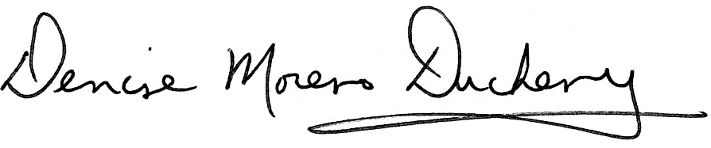

Denise Moreno Ducheny