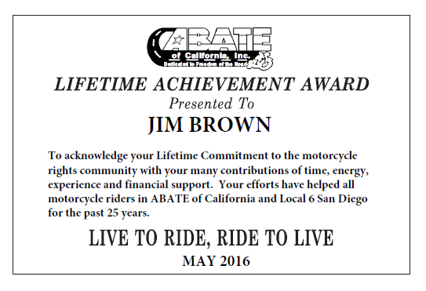

At our Local 6 (San Diego) ABATE meeting on August 7, we had the honor of presenting the ABATE Lifetime Achievement Award to Jim Brown. Jim has been a member of Local 6 since March of 1991. He’s served as Treasurer, is our Liaison to San Diego Harley Davidson, and has for many years had the distinction of being Officer Emeritus. We can always count on Jim to handle our 50-50 and raffles. He has worked on most of our events, political efforts, donated financially to the Local and State, and always been there when needed.

Jim is in his 80s, and has more energy and enthusiasm than many half his age. He proudly served and retired from the U.S. Navy in 1982 after 31 years of service. And before that he was in the U.S. Marine Corp Reserves for two years. He volunteers in his neighborhood and for many years helped cover graffiti and tagging…keep America beautiful.

Many of us have asked Jim to adopt us since he buys a new bike one or two times a year … mostly Harleys … but the latest being a new Spyder. Due to eyesight restrictions, he no longer rides at night, but you can bet you’ll see him pull up to Kate Sessions Park on the first Sunday of the month. Live to ride, ride to live for many more years, Jim. Thank you!